‘Parallel coordinates:

Shows audio features of around 44K songs, used to predict the characteristics of the most popular songs’

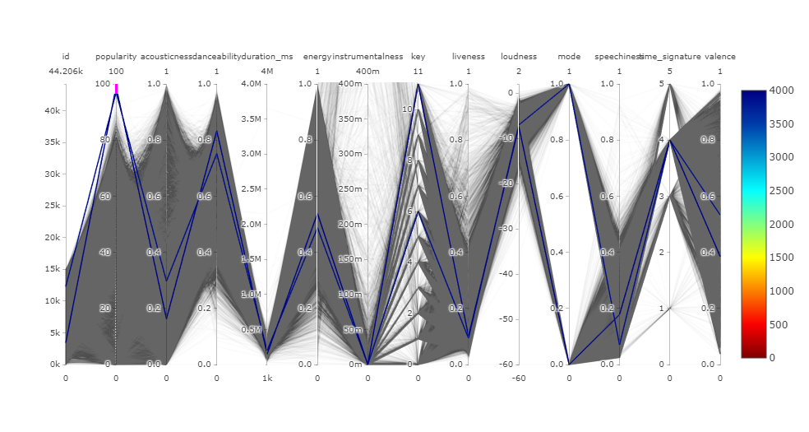

Characteristics of High popularity top 1000 out of 44 K in dataset -

‘Low acousticness: more electronic instruments, less string (example: guitar) instruments: prefer modern music’

‘High danceablity: good for dancing’

‘Low duration: Less than 5 minutes in length’

‘Medium energy: a balanced speed (neither too fast, nor too slow), medium noise level, medium loudness’

Low or 0 instrumentalness: fully vocal, more like Rap, less sounds like “Ooh” or “Aah”

Liveness 0.1: recorded music without audience, not live performance

Loudness 0.8: same as average for all tracks

Speechiness 0.1 or 0.2: same as average for all tracks, music, useless

Time signature 4: useless

‘Valence 0.4 or 0.6: only slightly positive or slightly negative relative to all other songs’ (not too positive or too negative)